*Required Fields
CUSTOMER DETAILS
*Name:
Reference ID:
*Institute Name / Department
*Address:
*Contact Number: | (Office) (Mobile)
*Email Address:
Principal Investigator / Supervisor:

TYPE OF SERVICE (please indicate with an “X”)
 | Service Name | Remarks
 | Primer Walking of Constructs – Single Pass  - Plasmid Preparation  - Primer Synthesis  - Sequencing, 1 to 1.5 kb/ week | 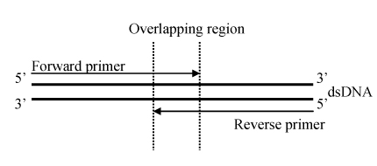
 | Primer Walking of Constructs – Bi-Directional  - Plasmid Preparation  - Primer Synthesis  - Sequencing, 1 to 1.5 kb/ week | 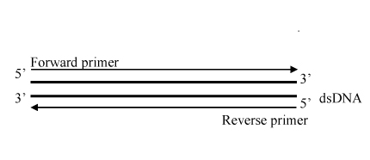

 | SAMPLE |  |  |  | PRIMER WALKING
S/N | Name | Type* | Total Size (bp) | Antibiotic# | Read Size  (bp) | Sequence of Initial Sequencing Primers (5’ to 3’) | Difficult Region? (Y / N / Unknown)
1 |  |  |  |  |  | Forward  Reverse
2 |  |  |  |  |  | Forward  Reverse
3 |  |  |  |  |  | Forward  Reverse
* Type of DNA: 1 = Purified Plasmid; 2 = Purified Fosmid/Cosmid; 3 = Purified BAC
# Ampicillin, Kanamycin, Chloramphenicol provided as free.

ADDITIONAL SERVICES (A separate fee is chargeable)
Quantity | Services
 | DNA verification by Restriction Digestion
 | Glycerol Stock

Have I met the sample preparation requirements?
Checklist (Please indicate with an “X”)
Submit ≥ 5 μg (100 ng/μl, 50 μl) of purified plasmid in either TE or 10 mM Tris-HCl (pH8.0) Elution Buffer

Samples submitted in 1.5 ml microcentrifuge tubes. Each tube should be clearly labeled using a permanent marker, with caps sealed with parafilm. Purified plasmid can be shipped at room temperature.

